MAKING MUSIC WITH MICRO:BIT

In this introduction to programming using the micro:bit, you will learn how to create music with their micro:bit.

**What you will need:**

* Web enabled device (PC, Tablet, Phone) with an up-to-date browser (Internet Explorer, Safari, Chrome)
* BBC micro:bit simulator ([www.microbit.co.uk/](https://www.microbit.co.uk/))
* BBC micro:bit (Optional)
* Speaker or headphones & two crocodile clips (Optional)

​

**Making music with Make Code:**  
  
The built-in music library in Make Code allows us to play music on our micro:bit.  
  
​To play a note we use the following command

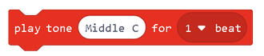

Where Middle C = note and 1 beat = duration.   
  
***Example***  
  
Try the following example:

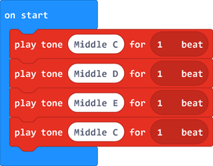

**Transcribing songs from sheet music**  
  
If we want to re-create our favourite songs on our micro:bit, we first need a basic understanding of sheet music.  
Here’s a reminder of the most common notes used in a musical score:  
  
  
***The Treble Clef***

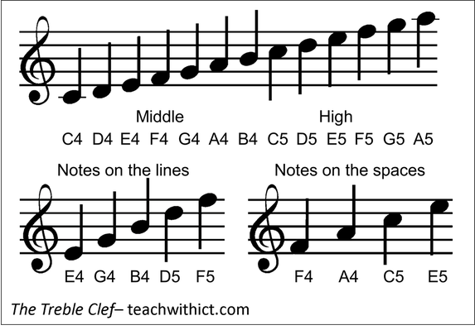

Below is the score for a very popular piece of music - Can you can guess what it is?

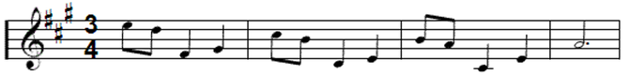

***Answer:*** Grande Valse (You may know it as the ‘Nokia Ringtone’)  
  
Did you notice the special **#** symbols at the start of the score. This shows that some of the notes are sharps. In this case, the sharp notes are:  
**F#, C#,** and **G#**  
  
In Make Code, sharp notes are selected by clicking on the ‘black notes’ in the drop-down keyboard:

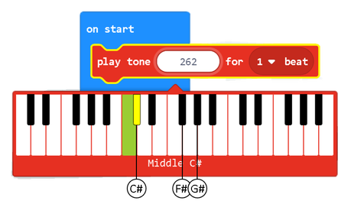

​Below is the music score for the Nokia Ringtone (this time with notes underneath).

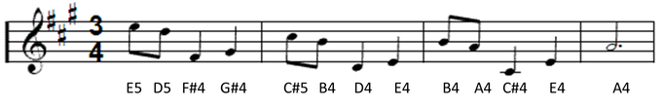

**​It’s all about the timing**  
  
If we look at the notes in a music score again, you will notice that they’re different shapes and colors. These different shapes and colors denote the timings. (See below)

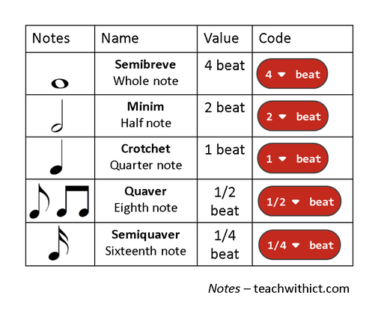

​Notice that some of the notes have a dot (or full stop) after them. For these notes, we need to multiply the duration by 1.5.

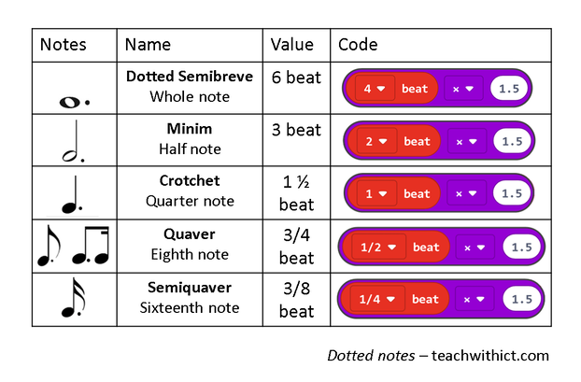

​Below is the score again however, this time, with timings (duration).

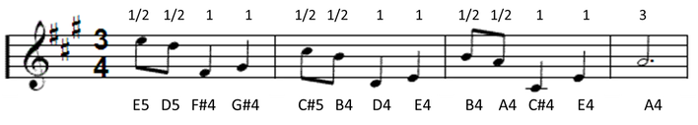

**Rests**  
Rests are natural pauses or breaks in a piece of music. Rests can be added to your code using the following command:

Rests are identified by the following symbols:

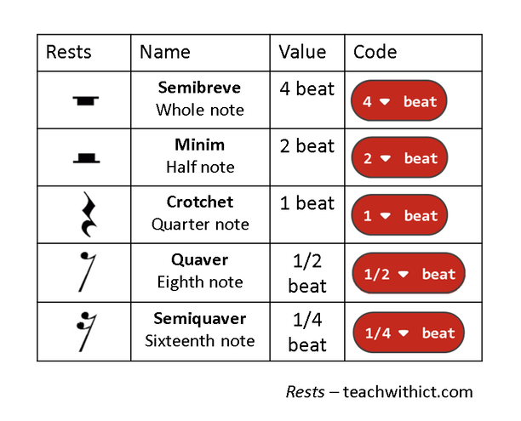

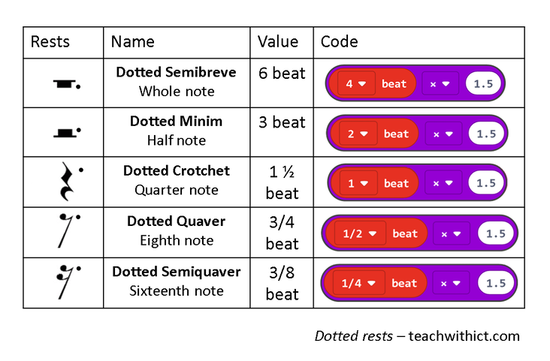

**Challenge**

* Program your micro:bit to play the Nokia ringtone.
* Use a loop to repeat the ringtone 4 times (or forever if you want to be really annoying!)
* Modify your code so that the ringtone only plays when you press the ‘A’ button